Lampiran 1. Surat Penelitian
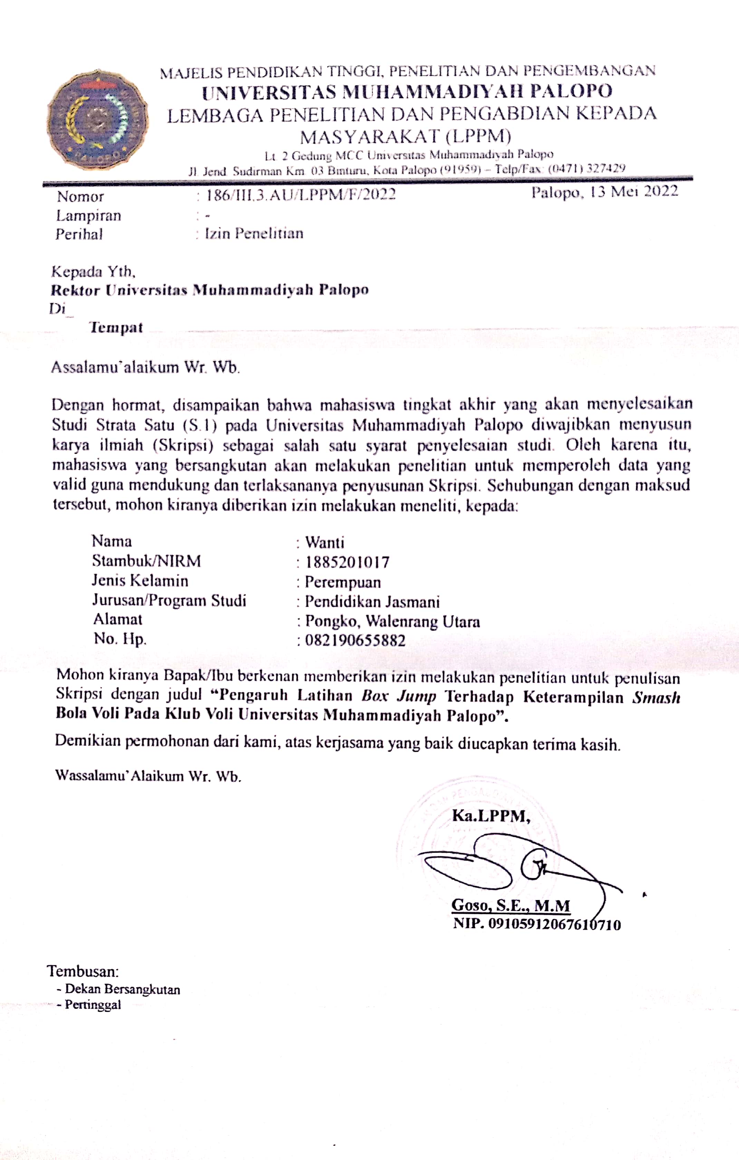
Lampiran 2. Uji Turnitin
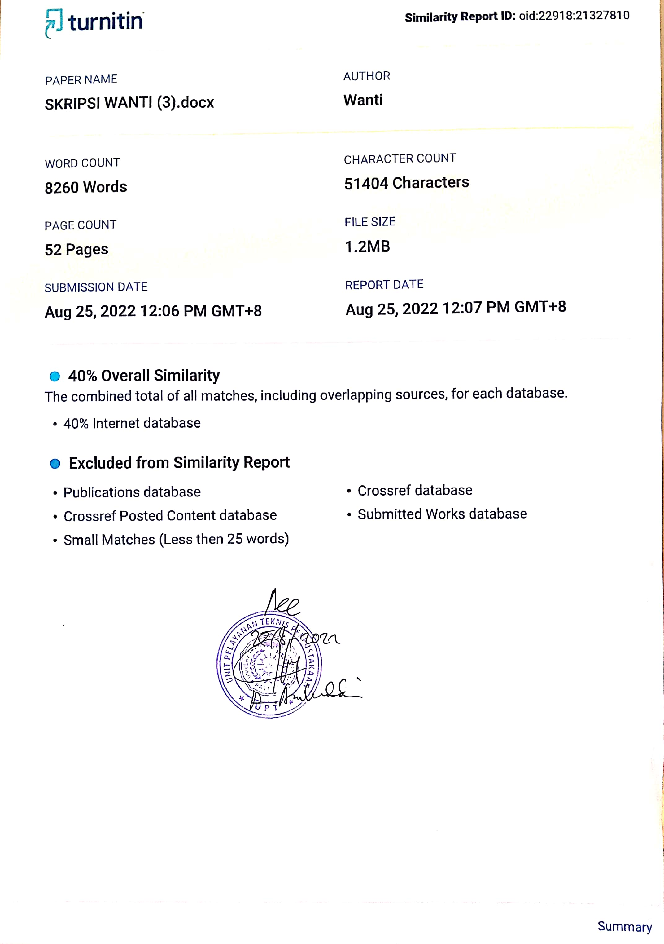

Lampiran 3. Data Mentah
No. | Nama Atlet | Pretest Ketepatan smash (10 Kali) | Posttest Ketepatan smash (10 Kali) | Pretest Vertical jump | Posttest Vertical jump
1 | Diki Wahyudi | 15 | 18 | 220 | 280
2 | Ismail | 12 | 16 | 230 | 296
3 | Ayyub | 11 | 14 | 215 | 276
4 | Resky Aditya Amir | 10 | 12 | 214 | 267
5 | Syahrul. I | 10 | 14 | 228 | 288
6 | Muhammad Zamroni | 10 | 14 | 226 | 290
7 | Emil Anggarianto | 12 | 16 | 220 | 278
8 | Aditio Arjun | 9 | 12 | 222 | 294
9 | Kanisius Kuma Lewar | 20 | 20 | 219 | 286
10 | Galeh Pangestu | 6 | 10 | 216 | 276
11 | Hikmal Ismail | 12 | 14 | 205 | 270
12 | Alfathra Mallaena | 14 | 16 | 224 | 286
13 | Unal Majid | 10 | 12 | 210 | 265
14 | Muh. Akmal | 14 | 18 | 225 | 282

Lampiran 4. Data Analisis Uji Deskriftif
Descriptives
Descriptive Statistics
 | N | Range | Minimum | Maximum | Sum | Mean | Std. Deviation
PRETEST VERTIKAL JUMP | 14 | 25 | 205 | 230 | 3074 | 219.57 | 7.046
POSTTEST VERTIKAL JUMP | 14 | 31 | 265 | 296 | 3934 | 281.00 | 9.640
PRETEST KETEPATAN SMASH | 14 | 14 | 6 | 20 | 165 | 11.79 | 3.309
POSTTEST KETEPATAN SMASH | 14 | 10 | 10 | 20 | 206 | 14.71 | 2.785
Valid N (listwise) | 14

Lampiran 5. Hasil Perhitungan Uji Normalitas
One-Sample Kolmogorov-Smirnov Test
 |  | PRETEST VERTIKAL JUMP | POSTTEST VERTIKAL JUMP | PRETEST KETEPATAN SMASH | POSTTEST KETEPATAN SMASH
N |  | 14 | 14 | 14 | 14
Normal Parameters^{a,b} | Mean | 219.57 | 281.00 | 11.79 | 14.71
 | Std. Deviation | 7.046 | 9.640 | 3.309 | 2.785
Most Extreme Differences | Absolute | .111 | .127 | .188 | .173
 | Positive | .069 | .087 | .188 | .173
 | Negative | -.111 | -.127 | -.152 | -.113
Test Statistic |  | .111 | .127 | .188 | .173
Asymp. Sig. (2-tailed) |  | .200^{c,d} | .200^{c,d} | .192^{c} | .200^{c,d}
a. Test distribution is Normal.
b. Calculated from data.
c. Lilliefors Significance Correction.
Lampiran 6. Hasil Perhitungan Uji Hogomenitas
- Uji Homogenitas Bleeb Test

Oneway
Test of Homogeneity of Variances
HASIL PRETEST POSTTEST
Levene Statistic | df1 | df2 | Sig.
1.798 | 1 | 26 | .192

ANOVA
HASIL PRETEST POSTTEST
 | Sum of Squares | df | Mean Square | F | Sig.
Between Groups | 26414.286 | 1 | 26414.286 | 370.541 | .000
Within Groups | 1853.429 | 26 | 71.286
Total | 28267.714 | 27

- Uji Homogenitas Tes Denyut Jantung Awal

Oneway
Test of Homogeneity of Variances
HASIL PRETEST POSTEST KETETPATAN SMASH
Levene Statistic | df1 | df2 | Sig.
.024 | 1 | 26 | .878

ANOVA
HASIL PRETEST POSTEST KETETPATAN SMASH
 | Sum of Squares | df | Mean Square | F | Sig.
Between Groups | 60.036 | 1 | 60.036 | 6.418 | .018
Within Groups | 243.214 | 26 | 9.354
Total | 303.250 | 27

Lampiran 7. Hasil Perhitungan Uji Paired Sample T-Test
Paired Samples Statistics
 |  | Mean | N | Std. Deviation | Std. Error Mean
Pair 1 | PRETEST VERTIKAL JUMP | 219.57 | 14 | 7.046 | 1.883
 | POSTTEST VERTIKAL JUMP | 281.00 | 14 | 9.640 | 2.576
Pair 2 | PRETEST KETEPATAN SMASH | 11.79 | 14 | 3.309 | .884
 | POSTTEST KETEPATAN SMASH | 14.71 | 14 | 2.785 | .744

Paired Samples Correlations
 |  | N | Correlation | Sig.
Pair 1 | PRETEST VERTIKAL JUMP & POSTTEST VERTIKAL JUMP | 14 | .861 | .000
Pair 2 | PRETEST KETEPATAN SMASH & POSTTEST KETEPATAN SMASH | 14 | .936 | .000

Paired Samples Test
 |  | Paired Differences |  |  |  |  | t | Df | Sig. (2-tailed)
 |  | Mean | Std. Deviation | Std. Error Mean | 95% Confidence Interval of the Difference
 |  |  |  |  | Lower | Upper
Pair 1 | PRETEST VERTIKAL JUMP - POSTTEST VERTIKAL JUMP | -61.429 | 5.064 | 1.354 | -64.353 | -58.504 | -45.384 | 13 | .000
Pair 2 | PRETEST KETEPATAN SMASH - POSTTEST KETEPATAN SMASH | -2.929 | 1.207 | .322 | -3.625 | -2.232 | -9.081 | 13 | .000

Lampiran 8. Hasil Dokumentasi
DOKUMENTASI PENELITIAN
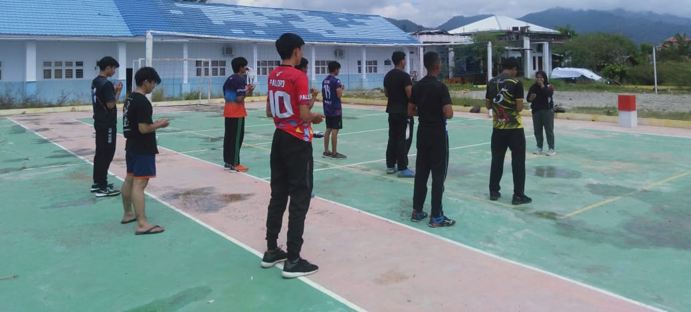
Gambar 1. Berdoa sebelum memulai kegiatan

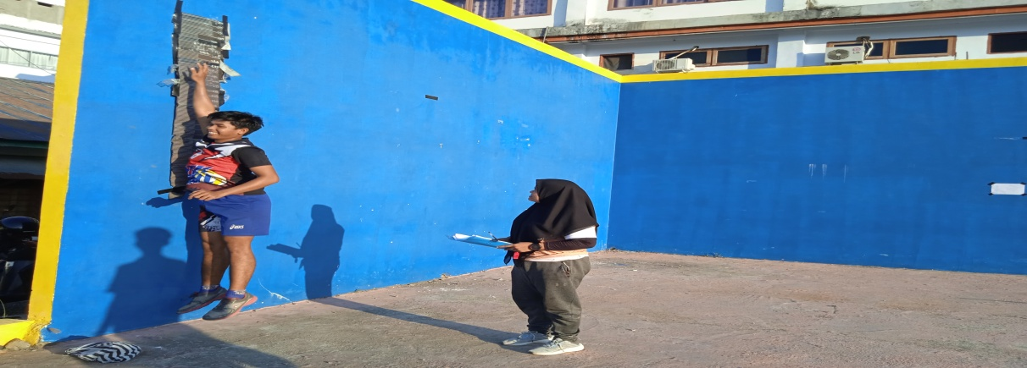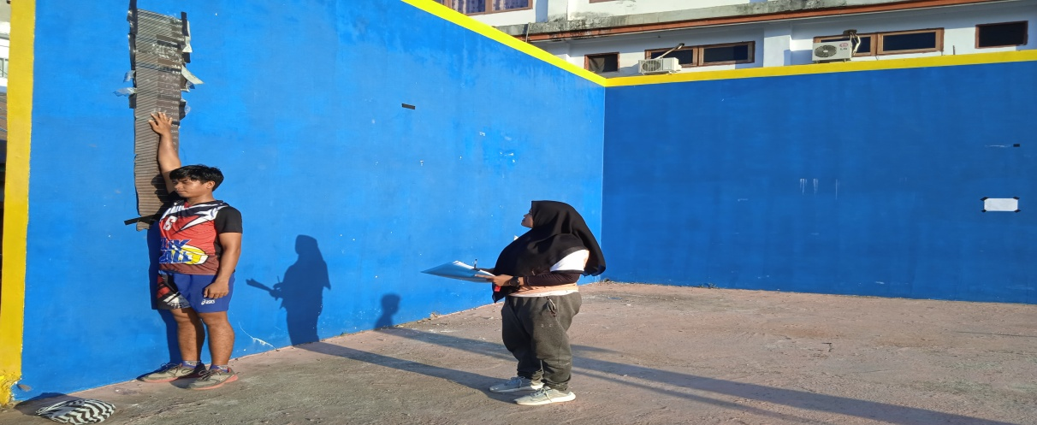

Gambar 2. Pretest vertical jump

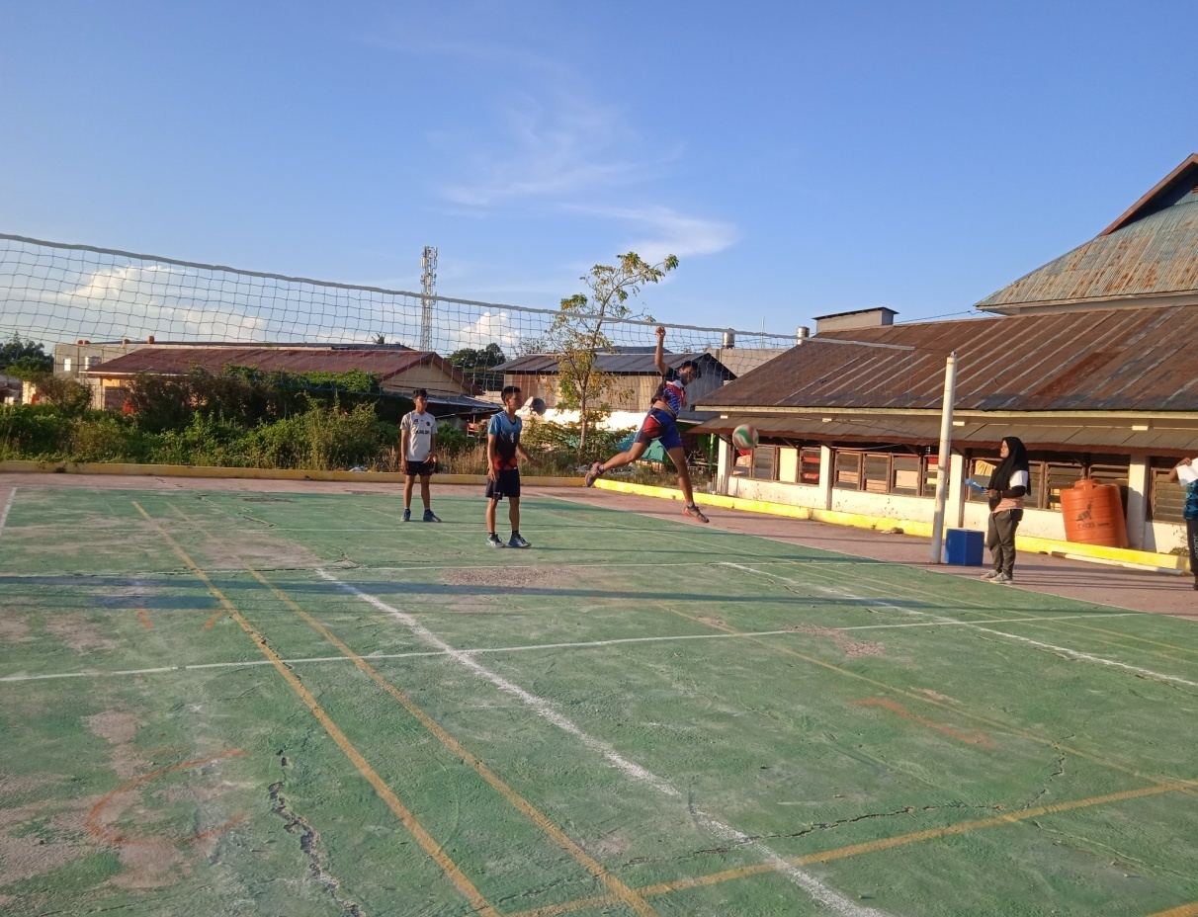
Gambar 3. Pretest tes ketepatan smash

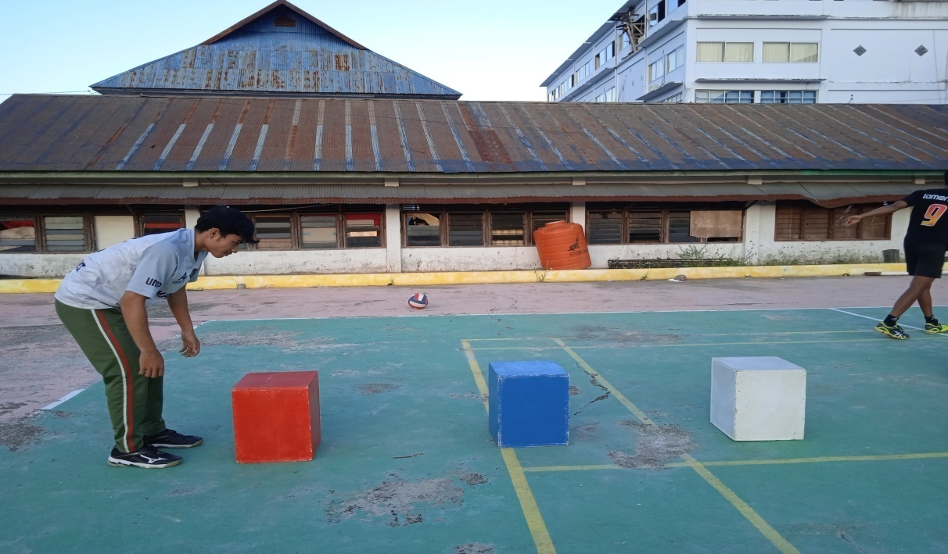
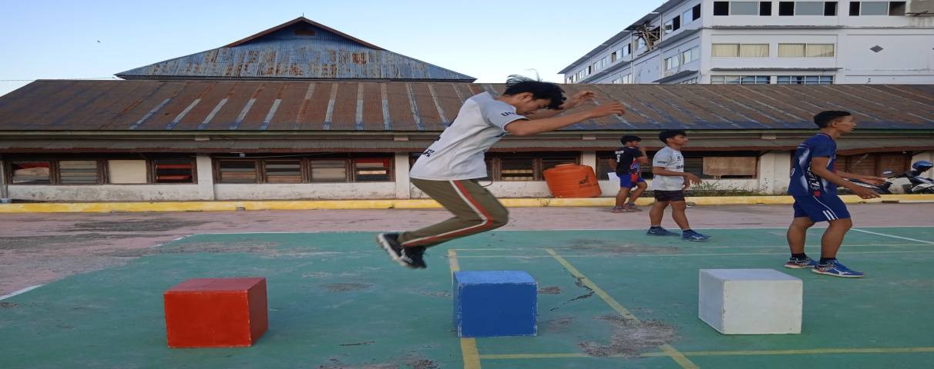
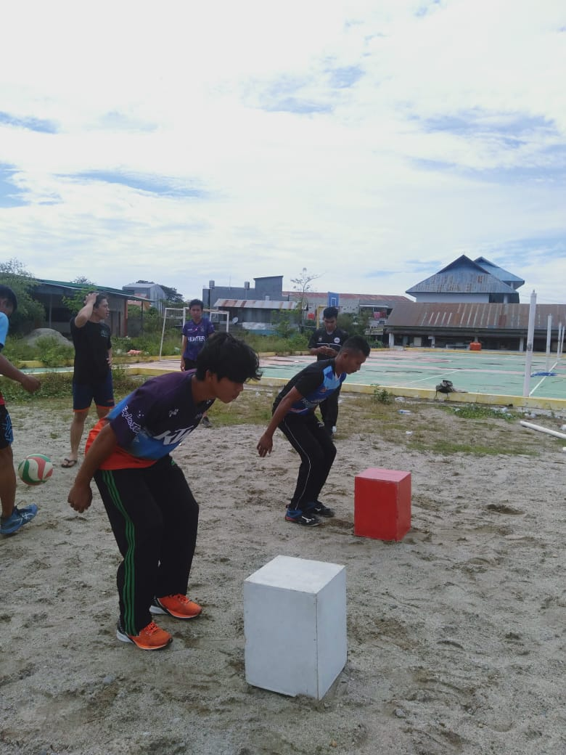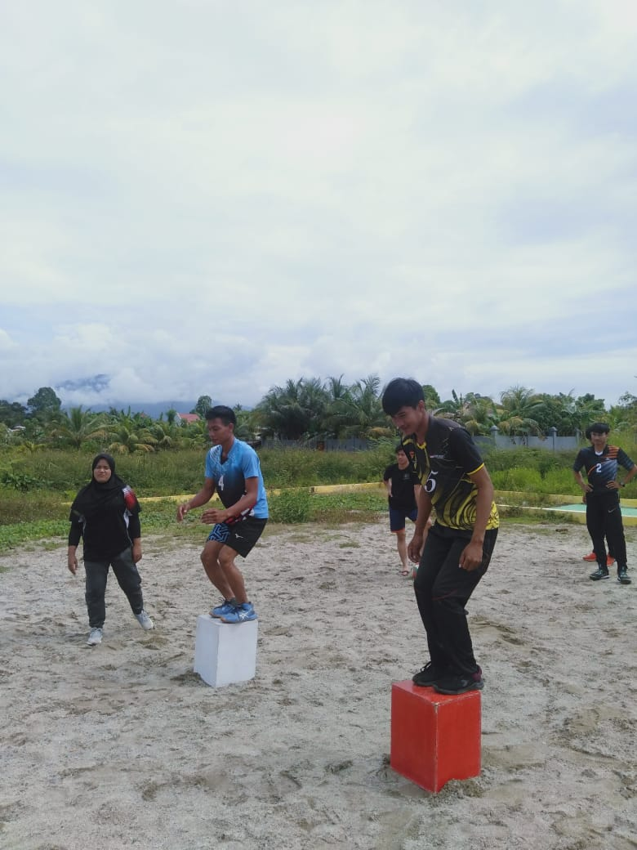
Gambar 4. Latihan box jump
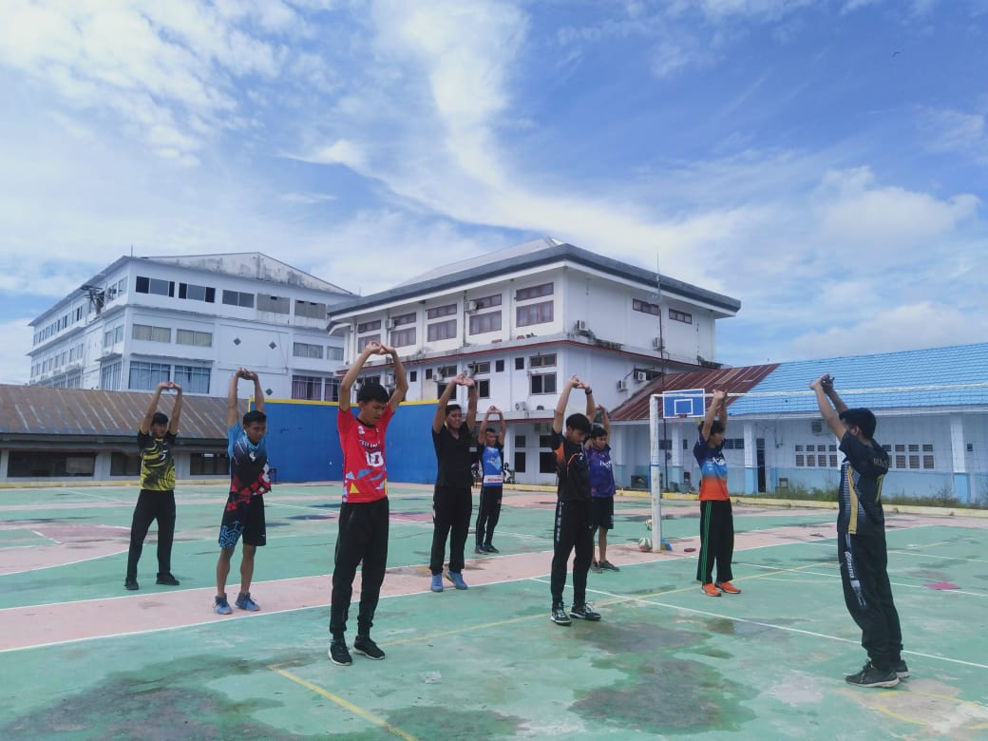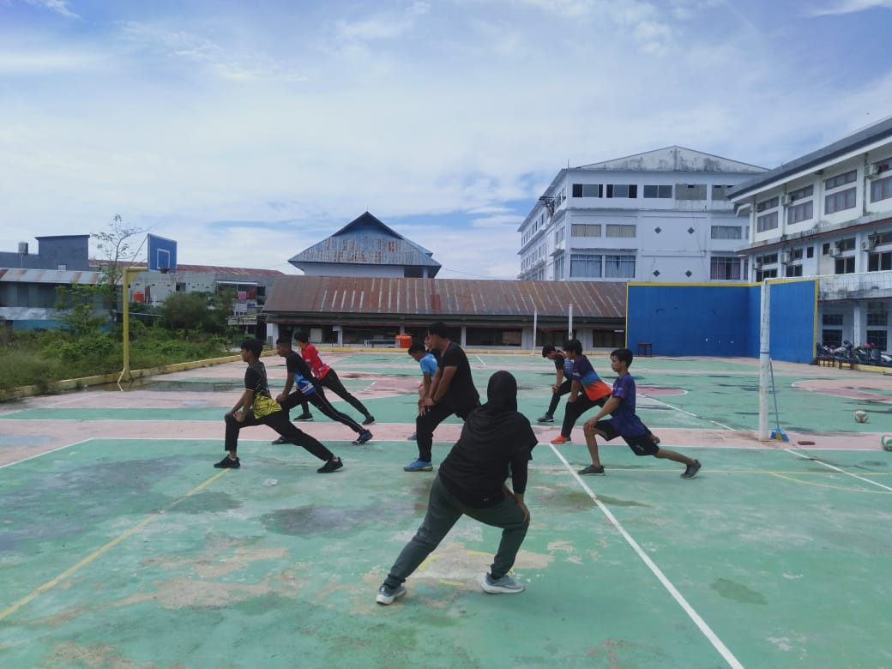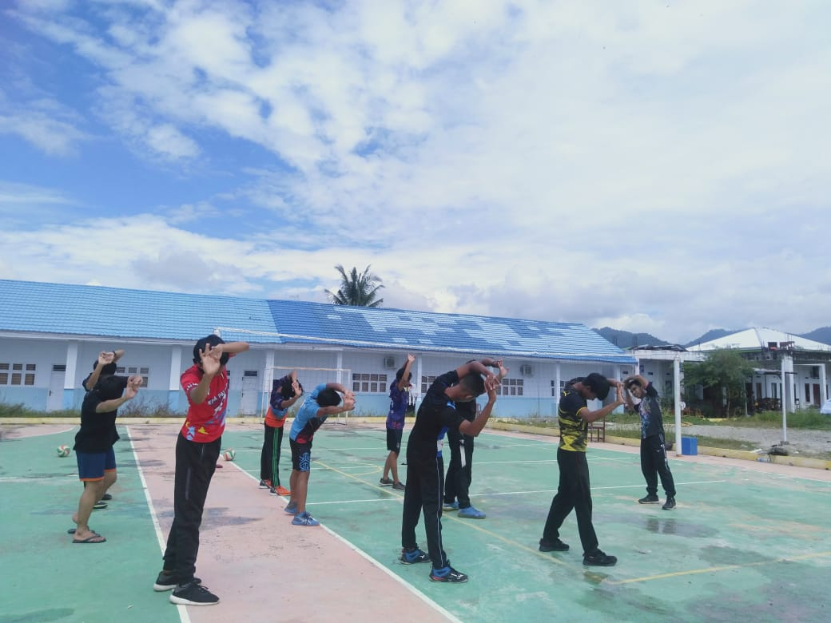

Gambar 5. Pemanasan

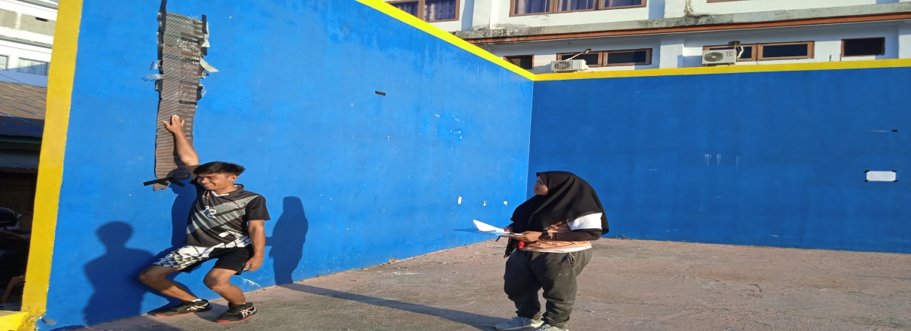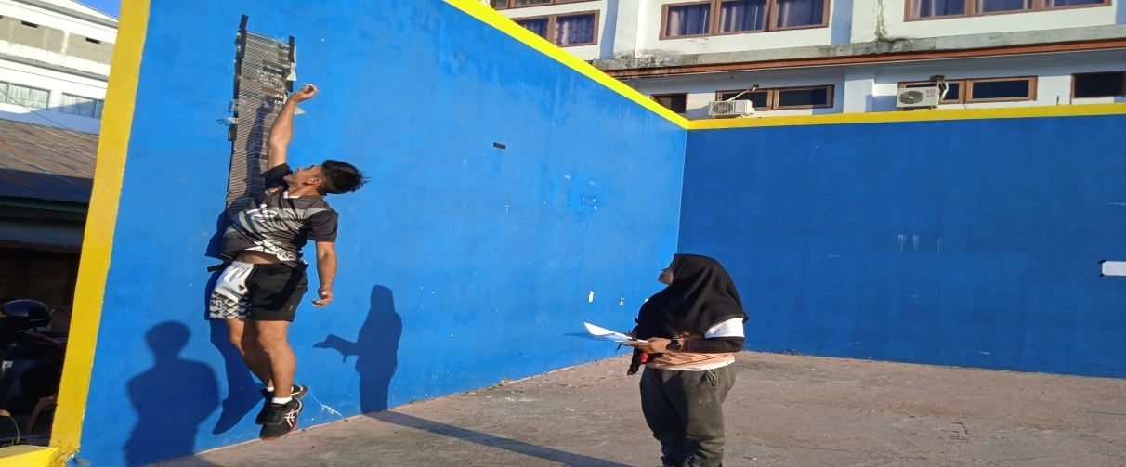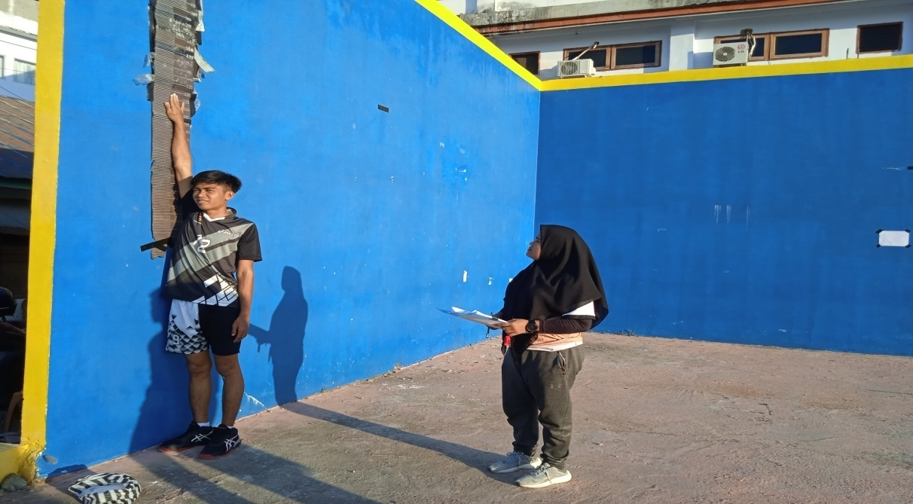
Gambar 6. Posttest vertical jump

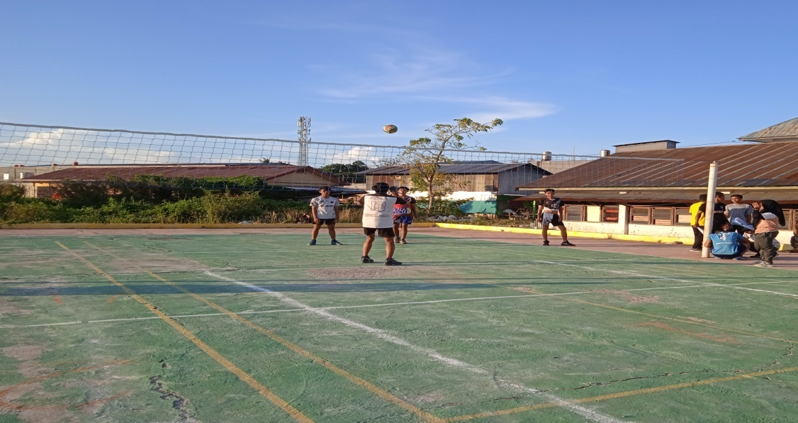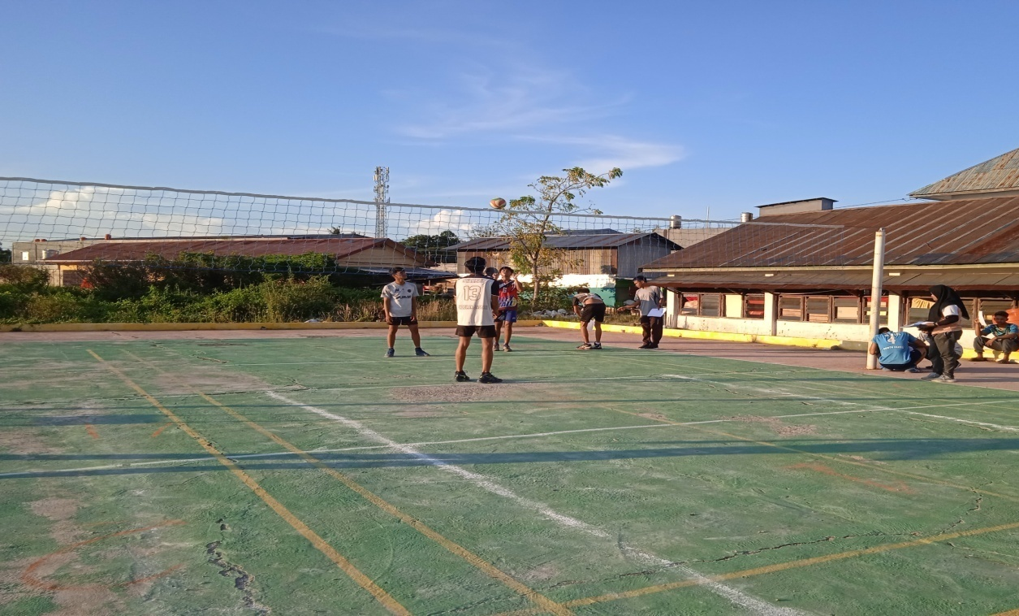
Gambar 7. Posttest Test Ketepatan Smash

BIODATA PENULIS

Wanti, lahir di to’nangka pada tanggal 30 april 1998, anak kedua dari 5 bersaudara buah kasih dari pasangan Ayahanda “ RISMANTO” dan Ibunda “ MASNA”. Penulis pertama kali menempuh pendidikan tepat pada umur 6 tahun di sekolah dasar (sd) SDN 005 TO’NANGKA dan lulus pada tahun 2011. Kemudian melanjutkan di SMPN 3 LAMASI dan lulus pada tahun 2014. Pada tahun 2017 lulus di SMK 9 LUWU. Pada tahun 2018 penulis terdaftar pada salah satu perguruan tinggi jurusan pendidikan jasmani di Universitas Muhammadiyah Palopo, dan Alhamdulillah selesi pada tahun 2022.
Berkat pertolongan ALLAH SWT, usaha dan disertai doa kedua orang tua, keluarga dan teman-teman dalam menjalani aktivitas akademik di perguruan tinggi Universitas Muhammadiyah Palopo, Alhamdulillah penulis dapat menyelsaikan tugas akhir dengan skripsi yang berjudul ” Pengaruh Latihan Box Jump Terhadap Keterampilan Smash Bola Voli Pada club Voli Universitas Muhammadiyah Palopo.

