

**FINANCIAL LITERACY IN GENERATION Z: A STUDY OF STUDENTS OF MUHAMMADIYAH UNIVERSITY OF PALOPO**

**Yosephine Injilitha Putri Lalimuga 1* , Goso 2 , Ibrahim Halim 3**

**a Department of Management, Faculty of Economics and Business, Muhammadiyah University of Palopo, Indonesia**

|  |  |
| --- | --- |
| **A R T I C L E I N F O** | **A B S T R A C T** |
| *Keywords :​​*  Financial literacy  Financial behavior  Locus of control  Financial management  Fintech | This study aims to measure the level of financial literacy, financial behavior and locus of control as independent variables, financial management as dependent variables and financial technology as moderating variables. The population in this study included students of Muhammadiyah University of Palopo in Palopo City. The sample of this study amounted to 240 students, selected using the census method where the researcher had determined the sampling by collecting data from the entire population that was the subject of the study. The data collection technique used a questionnaire. The results of this study indicate that financial literacy, financial behavior, and locus of control have a significant positive effect on financial management. The next result is that the financial technology variable also has a significant positive effect because it is able to moderate financial literacy, financial behavior, and locus of control on financial management. This study uses simple regression analysis and interaction tests or Moderated Regression Analysis (MRA), which are processed using the Statistical Package for Social Science (SPSS) version 26 program. |

**INTRODUCTION**

Financial literacy is a very important skill for Generation Z. With a good understanding of financial literacy, they can manage their finances wisely, create a stable financial life, and prepare for a brighter future. There are many resources available to build financial literacy skills, and it is essential for all of us to develop a generation that has strong financial literacy skills. Financial behavior in Generation Z is also very important in facing the financial challenges they will face in the future. Laturette (2021) said that Generation Z is a crucial component of the nation's energy supply, having the same human resources that experienced critical events in the same period. In carrying out tasks, Generation Z is much more practical than the previous generation Anggarini (2021) . Born between 1997-2012, namely the generation often referred to as Generation Z. This generation grew up in an environment that is easy with computers and the internet, so they are smart and technology literate Ningtyas (2019) The following are some of the issues of concern in this study , namely: the use of technology in financial management, financial education and awareness, long-term financial plans, and loans or debts. Coinciding with modern times, the world of technology and the internet is increasing, which is now mostly controlled by Generation Z.

Fungky (2021) stated that Financial management presents a number of problems for Generation Z, including low financial knowledge, significant investment risks, and concerns about financial planning and management. In terms of saving or investing, Generation Z is seen as a consumptive generation. Akbar & Armansyah (2023) said that Consumer bankruptcy often occurs in the younger generation due to a lack of understanding among the older generation regarding bankruptcy in the financial world (financial literacy). Ariani Damayanti & Ratna Gumilang (2023) said that Financial literacy has developed into a dynamic field where technology plays an important role in the digital era, going beyond old boundaries. Economic growth is now driven by technological advances. Zai (2023) said that the ability of technology to assist people in carrying out tasks related to the use of technology is what makes it useful in the financial sector in terms of promoting financial inclusion. Financial literacy is a person's ability to understand and manage finances. This includes the ability to budget, save, invest, and understand risk. Laturette (2021) said that To prevent financial difficulties, everyone needs to have a certain level of financial literacy. Low income is not the only factor that causes financial difficulties, poor money management can also be caused by mistakes made when using credit cards. Huston (2010) said that financial literacy can be applied to financial activities to increase lifetime consumption value projections (behaviors that improve a person's financial situation. *Locus of control* is a psychological concept that refers to a person's belief in the control they have over their environment or the circumstances they experience. Fatimah & Fathihan (2023) said that *locus of control* is known as where an individual handles the relationship between their activities and the results they have done. Julian B. Rotter said that *Locus of control* is divided into two types: Internal *Locus of Control* is Individuals believe that they have control over the outcomes and events in their lives through personal efforts and decisions, while External *Locus of Control* refers to an individual's belief that the outcomes in their lives are more determined by external factors, such as fate, luck, or the actions of others.

One of the reasons the author chose students of Universitas Muhammadiyah Palopo as the object of this study is because many of them do not have sufficient understanding of personal financial management, investment, or long-term financial planning. Students are also a group that is vulnerable to experiencing difficulties in managing finances. Generation Z is also known as digital *natives* , where they more often access financial information through platforms such as financial applications, social media or websites. Therefore, this study can also explore whether technology provides benefits or worsens financial understanding among students. This study aims to measure the level of influence of financial literacy, financial behavior, and *locus of control* on financial management and the impact of *financial technology* .

**\* Cor respondin g author .​**

***Email l addresses :*** [***putricantii15@gmail.com***](mailto:putricantii15@gmail.com)

**LITERATURE REVIEW**

**Theory Of Planned Behavior**

This theory was introduced by Icek Ajzen in 1985 as a development of *the Theory of Reasoned Action* (TRA) which was previously introduced by Ajzen and Fishbein in 1980. Atikah (2021) explains that *the Theory of Planned Behavior* (TPB) can help us understand individual behavior. *The Theory of Planned Behavior* (TPB) has also been widely used to study human behavior or reactions. The relationship between financial literacy, financial behavior, and *locus of control* can be seen in how financial literacy affects attitudes and perceived behavioral control in making financial decisions. Financial behavior is influenced by attitudes, social norms, and perceived behavioral control. In addition, *locus of control plays an important role in influencing how much control individuals feel they have over their financial decisions, which is closely related to the perceived behavioral control* aspect in TPB.

**Financial literacy**

Rahmawati (2024) stated that Financial literacy is an effort to solve financial management problems. According to Handayani (2023) someone who understands financial literacy will be more interested in utilizing various financial products and services available in a more effective way . Yushita (2017) someone who wants to improve their standard of living and pursue wealth must have various financial skills and information, including the ability to manage and use a certain amount of money. Kartini & Mashudi (2022) explain the indicators used in financial literacy, namely: financial knowledge, communication skills, personal financial management, decision-making ability, and confidence in making future financial plans. Financial literacy plays an important role in financial management. This is reinforced by research by Rumbianingrum & Wijayanka (2018) which states that there is a significant relationship between behavior and financial knowledge, so that someone who has higher financial literacy usually manages their money more wisely. Based on the previous explanation, the formulated hypothesis is:

**H 1 : Financial literacy has a significant influence on financial management.**

**Financial behavior**

Wanda Ayu Rasari & Endang Wulandari (2024) stated that financial behavior is the ability to handle daily financial resources through planning, budgeting, auditing, managing, organizing, searching, and storing. Arianti (2020) stated that financial behavior can be understood as a financial decision-making process that aims to balance personal interests with organizational goals. The success of financial management, where the flow of funds must be directed according to the established plan. Rahmayanti (2019) said that a person's financial behavior is determined by how responsibly they manage their finances. The emergence of Financial Behavior is the result of a person's strong desire to maintain their financial status in order to meet their basic needs ( Kholilah & Iramani, 2013) . Pokhrel (2024) explained that the indicators in this variable are: maintaining financial records, planning for the future and choosing financial products. A person who has responsible financial behavior tends to manage money well, such as making a budget, setting aside funds, controlling expenses, investing and making payments on time. This finding is also in line with the research of Budiarto & Susanti (2017) which shows that financial behavior has a positive and significant influence on financial management. Based on the previous explanation, the formulated hypothesis is:

**H 2 : Financial behavior has a significant positive effect on financial management.**

**Locus of control**

Abdul Raffie Naik (2015) said that Julian B. Rotter was the first person to discover the idea of " *Locus of Control* ." Rotter defines *Locus of Control* as a personality trait that helps explain a person's behavior. Alkautsar (2014) explains that *locus of control* is a person who can be used to respond to situations that arise but the impact of his actions on his life will change significantly. Atikah & Kurniawan (2021) say that a person is said to have an external *locus of control* when they feel that they have little influence over their circumstances. An external *locus of control* is someone who feels that events in his life are the result of conditions that cannot be controlled, such as fate, chance, luck, or destiny. In contrast, someone who has an internal *locus of control* believes that events in his life are the result of actions or decisions taken by himself. Musyarifah (2020) explains that the indicators of *the locus of control* variable are measured based on the following criteria: desire, restraining urges, controlling spending, and limiting the use of finances for more positive things. *Locus of control* in financial management refers to the process of taking preventive measures, such as saving, managing consumer behavior, and other actions related to financial management (Pradiningtyas & Lukiastuti, 2019). Empirical evidence from research conducted by Chen (2017) shows a positive relationship between *locus of control* and financial management. This is because a person's level of self-control affects how much they want to save and manage their expenses . So if that is the case, the researcher formulates the following hypothesis:

**H 3 : *locus of control* has a positive influence on financial management**

**Financial management**

Cahyani (2022) states that financial management is a person's effort to control income related to responsibility in managing, using and treating financial resources. Asandimitra & Kautsar (2019) say that financial management is a person's ability to plan finances including the ability to budget, manage, control, find and save funds effectively. NABI (2017) states that financial management is a tool used to measure a company's financial performance and assist in identifying business risks. Financial behavior reflects the level of individual responsibility in managing finances. Meanwhile, financial obligations include the process of financial management as well as the ability to utilize financial assets and other assets effectively and productively. Amri (2021) says that financial management tends to be consumptive with the act of spending money on wants rather than needs. Therefore, everyone needs to understand, obtain, and practice the importance of financial management for themselves. Hartina (2023) says that financial management can also be defined as a financial decision-making process that includes alignment between individual motivation and company goals. So as to encourage individuals to use money wisely by being discriminatory, effective, and efficient. Based on Musyarifah's (2020) research, there are important indicators for measuring financial management, namely: paying bills on time, making a budget for expenses and shopping, recording shopping expenses and saving regularly.

**Financial technology**

Alawi (2020) said that *financial technology* can streamline the payment transaction process and optimize banking services for customers. Technology and *financial services* come together to create *financial technology* , which ultimately changes the business model from traditional to moderate. Chi (2022) stated that *Fintech* has given consumers access to new and contemporary payment options to replace conventional payment systems that require bank accounts. Hasif & Ahmad (2019) said that *fintech* is one of the financial services that contributes significantly to increasing the effectiveness and efficiency of financial services. These payment services, which include QR code payments, mobile payments, and electronic money, can be developed on the internet or mobile phone network. Karo-Karo (2022) explained that the indicators for the use of financial applications are: practicality, security, efficiency, and recorded transaction history. In Ghosh's research (2020) explained that *fintech* can significantly improve individual financial literacy. *Fintech* also helps people improve their financial behavior for the better. Therefore, by increasing the accessibility of information, simplicity of management, and education. *Fintech* can help people feel more responsible for their finances and increase *locus of control.* Based on the description above, the hypothesis developed is:

**H 4 : Fintech is able to moderate financial literacy towards financial management**

**H 5 : Fintech is able to moderate financial behavior towards financial management.**

**H 6 : Fintech is able to moderate the locus of control** **towards financial management**

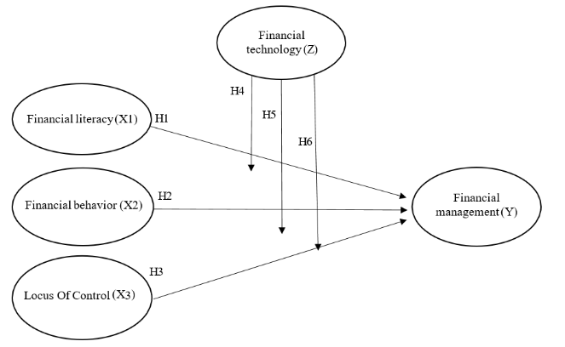

**Figure 1.** Conceptualization Framework

**RESEARCH METHODS**

This study uses quantitative methods. The types and methods of data collection use primary data obtained from the results of distributing questionnaires directly to students. The sampling technique used is the census method. The research instrument is used to collect data, while data analysis is carried out using quantitative or statistical methods to test the hypothesis. The population in this study were students of the University of Muhammadiyah Palopo, Faculty of Economics and Business, management study program (financial management concentration) in the odd semester consisting of: semesters 3, 5, and 7. The sample of this study amounted to 240 students. The data collection technique used a questionnaire distributed to respondents directly, or online via google from. Likert scale measurement is applied to measure responses to the questionnaire. This technique is used to find the relationship between one variable and another.

**RESULTS AND DISCUSSION**

**Instrument Test Results**

**Validity Test**

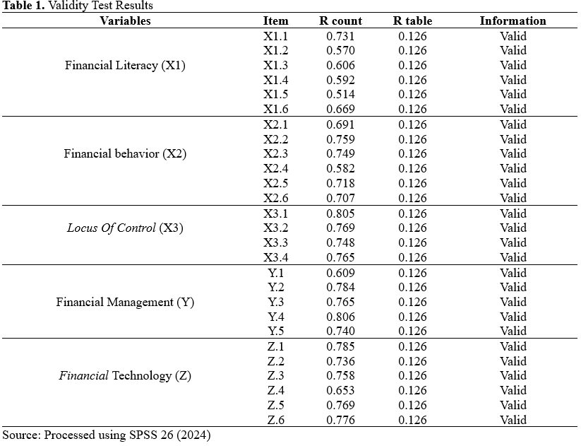

From the data results above, it can be seen that the data is valid because each questionnaire question has a significant value below 0.05 and the calculated R value is > R table.

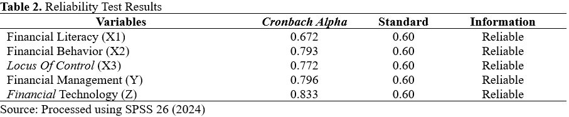**Reliability Test**

Based on the results of the reliability test above, it can be seen that all have a value greater than 0.60, so it can be concluded that all variables are reliable.

**Hypothesis Testing**

**Partial Test (T-Test)**

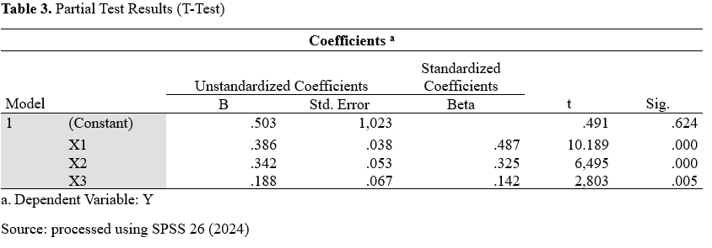

From table 3 above it can be explained that:

1. The test results show that t count > t table or 10.189 > 1.970 and the significant value is 0.000 < 0.05, so **H1** states that there is a significant influence between the financial literacy variable (X1) and financial management (Y).
2. The test results show that t count > t table or 6.495 > 1.970 and the significance value is 0.000 < 0.05, so **H2** states that there is a significant positive influence between the financial behavior variable (X2) on financial management (Y).
3. The test results show that t count > t table or 2.803 > 1.970 and the significant value is 0.005 < 0.05, so **H3** states that there is a positive influence between *the locus of control variable* (X3) on financial management (Y).

**F Test**

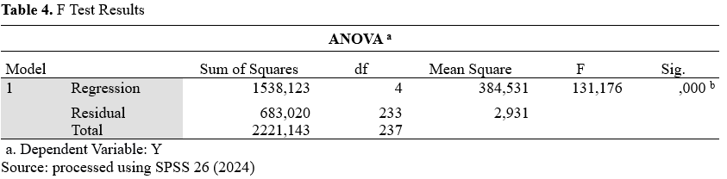

Based on the test results from table 4 above, it can be concluded that the F-count value obtained is 131.176, while the F-table value is 4.35. The results of this test indicate that the F-count value is greater than the F-table value and the significance value is smaller than the alpha value (0.000 <0.05). Thus, it can be concluded that there is a simultaneous influence of financial literacy X1, Financial Behavior, X2, Locus of Control X3 on Financial Management Y and Financial Technology Z as a moderating variable . Therefore, **hypothesis 4 (H4 ) , hypothesis 5 (H5) and hypothesis 6 (H6) are accepted.**

**Moderated Regression Analysis Test**

**Table 5.** Moderated Regression Analysis Test Results

|  |  |  |  |  |  |  |
| --- | --- | --- | --- | --- | --- | --- |
| **Coefficients a** | | | | | | |
| Model | | Unstandardized Coefficients | | Standardized Coefficients | t | Sig. |
| B | Std. Error | Beta |
| 1 | (Constant) | 14,536 | .984 |  | 14,774 | .000 |
| Z | -.384 | .084 | -.454 | -4.576 | .000 |
| X1Z | .014 | .002 | .671 | 9.311 | .000 |
| X2Z | .008 | .002 | .405 | 3.613 | .000 |
| X3Z | .006 | .003 | .201 | 2,338 | .020 |

a.Dependent Variable: Y

Source: processed using SPSS 26 (2024)

From table 5 above it can be explained that:

1. *Financial* technology as a moderating variable (Z) in the data test results listed in the table above, the coefficient value is -0.384, meaning that if financial technology increases by 1 item and the others are constant, it is predicted that financial management will experience a decrease of 0.384, meaning it has a negative effect.
2. Based on the test results of the data listed in the table above, it can be analyzed based on the significance coefficient. The value of the significance coefficient between variables X1 and Z is 0.000, which is smaller than 0.05. Therefore, it can be concluded that financial literacy can moderate the influence of *financial technology* on financial management.
3. Based on the test results of the data contained in the table above, it can be analyzed using the significance coefficient. The value of the significance coefficient between variables X2 and Z is 0.000, which is smaller than 0.05. Thus, it can be concluded that financial behavior can moderate the influence of *financial technology* on financial management.
4. Based on the test results of the data seen in the table above, it can be analyzed through the significance coefficient. The value of the significance coefficient between variables X3 and Z is 0.020, which is smaller than 0.05. Therefore, it can be concluded that *locus of control* can moderate the influence of *financial technology* on financial management.

**Determination Coefficient Test *(Adjuster R 2 )***

The determinant coefficient in a research result is indicated by value *(R 2 ) or Adjusted R Square* . The following are the results of testing a determinant coefficient.

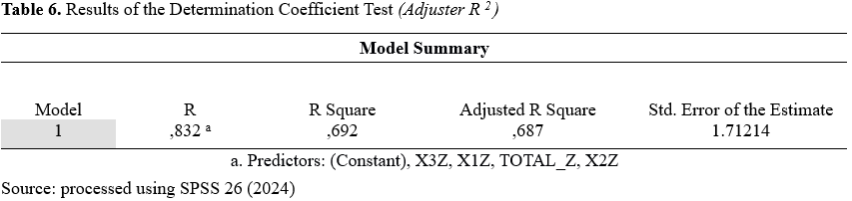

The results of the data test above show that the R Square value is 0.692 or 69.2%. This means that the variation in the strength of the influence of Financial Literacy (X1), Financial Behavior (X2), *Locus of Control* (X3) through *Financial Technology* (Z) on the Financial Management variable (Y) is 69.2%. The rest, which is 31.8%, is determined by other variables not examined in this study.

**Discussion**

**The influence of financial literacy on financial management**

The results of the study indicate that financial literacy (X1 ) has a significant influence on financial management (Y) in students of the University of Muhammadiyah Palopo. This is supported by the results of the t-test which shows a significant value of 0.000 <0.05 and a calculated t value of 10.189> t table of 1.970. Thus, it can be said that financial literacy has a positive impact on financial management for students. This finding is in line with research conducted by Ni Luh (2021) , which also states that financial literacy has a significant influence on financial management.

**The influence of financial behavior on financial management**

The results of this study reveal that financial behavior (X2 ) has a significant influence on financial management (Y) of students at the University of Muhammadiyah Palopo. This is supported by the results of the t-test which shows that the significant value is 0.000 <0.05 and the calculated t value is 6.495> t table of 1.970. Thus, the better a person is at implementing financial aspects, the wiser the financial behavior shown and the more effective the financial management carried out. This finding is in line with Mustika's research (2022) which states that financial behavior has a significant effect on financial management.

**The influence of locus of control on financial management**

The results of this study indicate that *locus of control* (X3 ) has a significant positive effect on financial management (Y) of students at the University of Muhammadiyah Palopo. This is supported by the results of the t-test which shows that the significant value is 0.000 <0.05 and the calculated t value is 2.803> t table of 1.970. Thus, the test carried out proved that *locus of control* has a significant positive effect on financial management. This means that the better a person's *locus of control* , the better the financial management they carry out. This finding is in line with the research of Reviandani (2022) which states that *locus of control* has a significant effect on financial management.

**financial technology (moderation variable) on financial literacy in financial management**

This study reveals that *fintech* (Z)can moderate the influence of financial literacy (X1 ) on financial management (Y) of students at the University of Muhammadiyah Palopo. This is supported by the results of the *Moderated Regression Analysis* (MRA) test which shows that the significance coefficient value between the financial literacy variables (X1 ) and *fintech* (Z) is 0.000, which is less than 0.05. Thus, *fintech* can help individuals to better understand and manage their finances better through access to information and financial planning tools provided by various financial applications. This finding is in line with Mudrikah's research (2021) which states that *fintech* has a significant influence on financial literacy in financial management.

**financial technology (moderation variable) on financial behavior in financial management**

The results of this study indicate that fintech (Z) can moderate the influence of financial behavior (X2 ) on financial management (Y) of students at the University of Muhammadiyah Palopo. This is supported by the results of the *Moderated Regression Analysis* (MRA) test which shows that the significance coefficient value between the financial behavior variables (X2 ) and fintech (Z) is 0.000, which is less than 0.05. Thus, *fintech* can help improve wiser financial behavior in managing finances. This study also revealed that the use of *fintech* can strengthen financial behavior, which in turn increases smarter and more planned decision making. This finding is supported by research by Erlangga & Krisnawati (2020) which states that the more often students use *fintech* , the better their financial behavior. With research results showing a positive and significant influence.

**financial technology (moderation variable) on locus of control in financial management**

The results of this study indicate that *fintech* (Z) can moderate *the locus of control* (X3 ) in financial management (Y) of students at the University of Muhammadiyah Palopo. This is supported by the results of the *Moderated Regression Analysis* (MRA) test which shows that the significance coefficient value between *the locus of control variables* (X3 ) and *fintech* (Z) is 0.020, which is less than 0.05. Thus, *fintech* can strengthen *the locus of control* , where individuals feel they have greater control over their finances. This study also revealed that the use of *fintech* can improve financial management through personal control, both in budget management, debt, and investment. This finding is supported by Hermawati's research (2023) which states that *fintech* has a significant effect on *locus of control* in financial management.

**Conclusion and suggestions**

1. **conclusion**

Based on research on financial literacy in generation Z at Muhammadiyah University of Palopo, it can be concluded that financial literacy is very important in managing individual finances. Good financial literacy helps individuals to plan long-term finances, avoid impulsive decisions, and use financial resources more effectively. This study also shows that financial technology strengthens the relationship between financial literacy, financial behavior, and locus of control in financial management. Financial technology can help individuals with low financial literacy to manage their finances better, by providing easy access to information, planning tools, and financial transparency. Therefore, it is important to continue to increase students' awareness of financial literacy and the use of financial technology for better financial planning in the future.

1. **Suggestion**

For further research, it is hoped that it can add samples or expand the scope of samples which can later be used not only at Muhammadiyah University of Palopo but also at other universities in Palopo City, and can compare the level of financial management among students at each university in Palopo City.

**References**

Abdul Raffie Naik. (2015). A Study on Locus of Control among College Students of Gulbarga City. *International Journal of Indian Psychology* , *2* (4). https://doi.org/10.25215/0204.027

Akbar, RP, & Armansyah, RF (2023). Financial Behavior of Generation Z Based on Literacy. *Scientific Journal of Management and Business* , *2* (2), 107–124.

Alawi, NM, Asih, VS, & Sobana, DH (2020). The Influence of Financial Literacy and Inclusion of UIN Sunan Gunung Djati Bandung Students on the Use of Financial Technology Systems. *Maps Journal (Islamic Banking Management)* , *4* (1), 36–44. https://doi.org/10.32483/maps.v4i1.48

Alkautsar, M. (2014). Locus of control, professional commitment and dysfunctional audit behavior. *International Journal of Humanities and Management Sciences (IJHMS)* , *2* (1), 35–38.

Amri, A., Widyastuti, T., Bahri, S., & Ramdani, Z. (2021). Is it true that spiritual intelligence determines a person's financial management behavior? A postgraduate student's perspective. *Journal of Perspectives* , *5* (1), 1. https://doi.org/10.15575/jp.v5i1.109

Anggarini, DR, Putri, AD, & Lina, LF (2021). Financial Literacy for Generation Z at MAN 1 Pesawaran. *Indonesian Community Service Journal* , *1* (1), 147–152. https://doi.org/10.54082/jamsi.42

Ariani Damayanti, W., & Ratna Gumilang, R. (2023). The Role of Financial Technology in Improving Financial Literacy in Generation Z. *Coopetition: Scientific Journal of Management* , *14* (3), 525–534. https://doi.org/10.32670/coopetition.v14i3.3850

Arianti, BF (2020). The Influence of Income and Financial Behavior on Financial Literacy Through Investment Decisions as Intervening Variables. *Journal of Accounting* , *10* (1), 13–36. https://doi.org/10.33369/j.akuntansi.10.1.13-36

Asandimitra, N., & Kautsar, A. (2019). The influence of financial information, financial self-efficacy, and emotional intelligence to financial management behavior of female lecturers. *Humanities and Social Sciences Reviews* , *7* (6), 1112–1124. https://doi.org/10.18510/hssr.2019.76160

Atikah, A., & Kurniawan, RR (2021). The Influence of Financial Literacy, Locus of Control, and Financial Self Efficacy on Financial Management Behavior. *JMB: Journal of Management and Business* , *10* (2), 284–297. https://doi.org/10.31000/jmb.v10i2.5132

Budiarto, A., & Susanti. (2017). The Influence of Financial Literacy, Overconfidence, Regret Aversion Bias, and Risk Tolerance on Investment Decisions. *Journal of Management Science* , *5* (2), 1–9.

Cahyani, NR (2022). The Influence of Financial Literacy, Locus of Control, Income, and Hedonism Lifestyle on Financial Management Behavior of Generation Z. *Journal of Management Science* , *10* , 421–432. https://journal.unesa.ac.id/index.php/jim/article/view/17736

Chen, Y., Koenigsberg, O., & John, Z. (2017). Pay-as-you-wish pricing. *Marketing Science* , *36* (5), 780–791. https://doi.org/10.1287/mksc.2017.1032

Chi, N. M. (2022). Some Legal Issues About Fintech in Payment Activities in Vietnam. *International Transaction Journal of Engineering* , *13* (5), 1–15. https://doi.org/10.14456/ITJEMAST.2022.100

Erlangga, MY, & Krisnawati, A. (2020). The Influence of Fintech Payment on Students' Financial Management Behavior. *Journal of Management and Business Research* , *15* (1), 53. https://doi.org/10.21460/jrmb.2020.151.348

Fatimah, SN, & Fathihani, F. (2023). The Influence of Financial Literacy, Lifestyle, and Locus of Control on the Financial Behavior of Generation Z in a Cashless Society. *Journal of Applied Management Science* , *4* (6), 868–877. https://www.dinastirev.org/JIMT/article/view/1637

Fungky, T., Sari, TP, & Sanjaya, VF (2021). The Influence of Lifestyle and Financial Literacy on Generation Z's Consumptive Behavior during the Pandemic (Case Study of Sharia Business Management Students, Uin Raden Intan Lampung, Class of 2019). *Valuation Journal: Scientific Journal of Management and Entrepreneurship* , *1* (1), 82–98.

Ghosh, J., Ganguly, S., Mondal, D., Pandey, P., Dabkara, D., & Biswas, B. (2020). Perspective of Oncology Patients During COVID-19 Pandemic: A Prospective Observational Study From India. *JCO Global Oncology* , *6* , 844–851. https://doi.org/10.1200/go.20.00172

Hartina, Goso, G., & Palatte, MH (2023). Analysis of the Impact of Financial Literacy and Finance on the Financial Performance of MSMEs. *SEIKO: Journal of Management & Business* , *6* (1), 644–651. https://doi.org/10.37531/sejaman.v6i1.3874

Hasif, M., & Ahmad, K. (2019). Factors Affecting the Acceptance of Financial Technology among Asnaf for the Distribution of Zakat in Selangor- A Study Using UTAUT. *Journal of Islamic Finance (Special Issue)* , *2117* , 35–46.

Hermawati, SN, Assyarofi, MR, & Rahmaningrum, SA (2023). *The Role of Locus of Control in Mediating the Influence of Financial Literacy and Financial Technology on Financial Management Behavior in UIN Raden Mas Said Surakarta Students* . *3* (2), 1–17.

Huston, S. J. (2010). Measuring Financial Literacy. *Journal of Consumer Affairs* , *44* (2), 296–316. https://doi.org/10.1111/j.1745-6606.2010.01170.x

Karo-Karo, L. (2022). *The Influence of Financial Literacy and Financial Technology on Student Consumptive Behavior* . 1–151.

Kartini, T., & Mashudi, U. (2022). Financial Literacy of Boarding House Students, Prospective Economics Educators, FKIP, University of Jember. *PROMOSI (Journal of Economic Education)* , *10* (2), 154–164. https://doi.org/10.24127/pro.v10i2.6648

Kholilah, N. Al, & Iramani, R. (2013). Study of Financial Management Behavior in Surabaya Society. *Journal of Business and Banking* , *3* (1), 69. https://doi.org/10.14414/jbb.v3i1.255

Laturette, K., Widianingsih, LP, & Subandi, L. (2021). Financial Literacy in Generation Z. *Journal of Accounting Education (JPAK)* , *9* (1), 131–139. https://doi.org/10.26740/jpak.v9n1.p131-139

Mudrikah, A. (2021). The Influence of Financial Literacy Level on Interest in Using Financial Technology Products in FEBI UIN North Sumatra Students. *ETNIK: Journal of Economics and Engineering* , *1* (2), 57–68. https://doi.org/10.54543/etnik.v1i2.23

Mustika, nilawaty yusuf and victorson taruh. (2022). The Influence of Financial Literacy, Financial Attitudes and Academic Ability on the Financial Management Behavior of Accounting Students, Faculty of Economics, Gorontalo State University. *Cmr* , *1* (1), 280–297. https://doi.org/10.1515/9783110564921-019

Musyarifah, N. (2020). The Influence of Self-Control, Financial Literacy, and Gender on Individual Financial Management of Students. *Journal of Management* , *Vol* - *1* , 43–44. https://journal.unesa.ac.id/index.php/jepk/article/view/752

PROPHET, AA (2017). *Impact of sectors and political influence on financial distress across Pakistani public listed firms* . http://eprints.utm.my/79212/1/AghaAmadNabiPFM2017.pdf

Ni Luh, PKD, Agus, WSG, & Ni Putu, YA (2021). The Influence of Financial Literacy, Hedonistic Lifestyle, and Income on Financial Management of UNMAS Students. *Jurnal Emas* , *2* , 74–85.

Ningtyas, MN (2019). Financial Literacy in the Millennial Generation. *Asian Journal of Business and Economics* , *13* (1), 20–27. https://doi.org/10.32812/jibeka.v13i1.111

Pokhrel, S. (2024). *The Influence of Financial Behavior on Financial Literacy in Students of the Faculty of Economics, Muhammadiyah University of West Sumatra* . *15* (1), 37–48.

Rahmawati, M., Lathifaturahmah, L., Aryanti, S., Tamara Dewi, N., & Idrus, S. (2024). The Influence of Financial Management on Generation Z for Long-Term Financial Well-Being. *Blantika: Multidisciplinary Journal* , *2* (6), 628–634. https://doi.org/10.57096/blantika.v2i6.158

Rahmayanti, W., Sri Nuryani, H., & Salam, A. (2019). The Influence of Financial Attitudes and Financial Behavior on Financial Literacy. *Journal of Management and Business* , *2* (1). https://doi.org/10.37673/jmb.v2i1.267

Reviandani, W. (2022). *The Influence of Locus of Control, Financial Knowledge and Parental Income on Financial Management Behavior (Study on New Students of the Management Study Program in 2021, Muhammadiyah University of Gresik)* . *7* (2), 68–77.

Rumbianingrum, W., & Wijayanka, C. (2018). The Influence of Financial Literacy on MSME Financial Management. *Journal of Management and Business (Almana)* , *2* (3), 155.

Wanda Ayu Rasari, & Endang Wulandari. (2024). The Influence of Financial Literacy and Income on Students' Investment Decisions. *National Seminar on Tourism and Entrepreneurship (SNPK)* , *3* , 594–601. https://doi.org/10.36441/snpk.vol3.2024.277

Yushita, AN (2017). The Importance of Financial Literacy for Personal Financial Management. *Nominal, Barometer of Accounting and Management Research* , *6* (1). https://doi.org/10.21831/nominal.v6i1.14330

Zai, VAL, Harefa, I., Bu'ulolo, NA, & Telaumbanua, A. (2023). Analysis of the Role of Financial Technology and Financial Literacy. *Journal of Social Science Research* , *4* (2), 1511–1527.